Report for Assignment 1
Submitted By: Ritwik Gupta (102303096)

Q1. Hello world in openMP
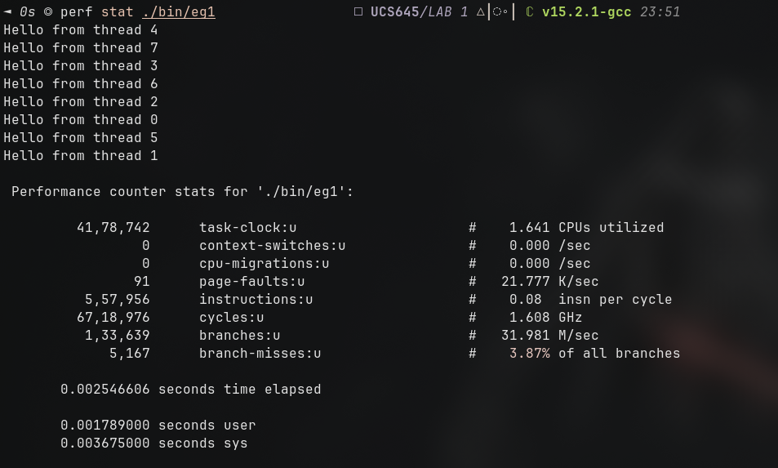
Fig. Output of perf stat
Inferences:

1. Parallel Execution and Thread Scheduling
- Non-Deterministic Execution: The output shows threads printing in a non-sequential order (4, 7, 3, 6, 2, 0, 5, 1). This confirms that OpenMP threads are scheduled independently by the OS, and the order of execution is not guaranteed.
- Thread Count: Exactly 8 threads (0 through 7) reported back, which perfectly matches the 8 logical cores of the Intel® Core™ i7-8550U. This indicates the OpenMP runtime defaulted to the maximum available hardware threads.

2. CPU Utilization and Scaling
- Multi-Core Engagement: The task-clock:u shows 1.641 CPUs utilized. While higher than a single-threaded process, it is significantly lower than the theoretical maximum of 8.0. This suggests that for such a trivial task (a single print statement), the overhead of spawning and managing threads outweighs the actual computation time.
- Frequency Scaling: The processor ran at 1.608 GHz during this task, which is slightly below the base clock of 1.80GHz. This is common for very short-lived bursts where the CPU doesn't have time to ramp up to its maximum turbo frequency.

3. Pipeline Efficiency (IPC)
- Low Instruction Throughput: The Instructions Per Cycle (IPC) is extremely low at 0.08. In a high-performance scenario, an i7-8550U can achieve an IPC of 2.0 or higher.
- Bottleneck Analysis: The low IPC indicates the CPU spent the vast majority of its cycles stalled. This is not due to complex math, but rather the I/O bottleneck of writing to stdout (the terminal) and the synchronization overhead within the OpenMP library and the printf function (which is thread-safe and involves locking).

4. Branching and Memory
- Branch Predictor Accuracy: The branch miss rate is 3.87%. While seemingly low, for a program that is essentially a single loop/fork, this indicates that the setup code for the OpenMP parallel region involves several conditional checks and jump instructions that weren't perfectly predicted.
- Minimal Memory Stress: With only 91 page-faults, the program has a very small memory footprint. These faults are likely "minor" faults related to loading the OpenMP shared libraries (libgomp) and the initial allocation of thread stacks.

5. Time and Overhead
- System vs. User Time: The sys time (0.0036s) is significantly higher than the user time (0.0017s). This confirms that the program spent more time in the kernel—likely handling thread creation and synchronization—than it did executing the user’s printf logic.
- Profiling Overhead: The use of the -pg flag (for gprof) and -O3 optimization was likely negligible here. In fact, -O3 cannot optimize away the parallel region because printf has side effects.

